# IT Professional Trainings and Certification

# Dominique Q. Adrias

# EY Analytics - Data visualization - Silver (2020)

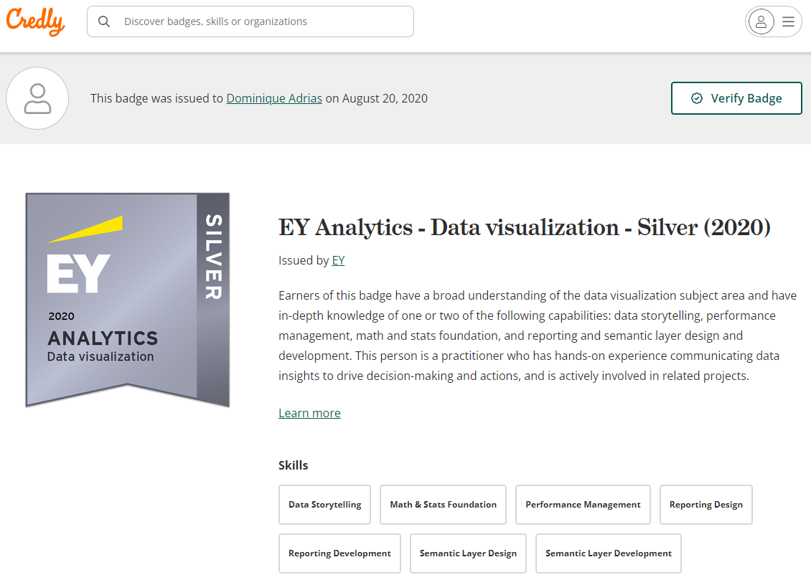

[EY Analytics - Data visualization - Silver (2020) - Credly](https://www.credly.com/badges/5907009a-ea06-47ff-b8df-8dbe54d5caa7)

# EY Analytics - Data architecture - Bronze (2020)

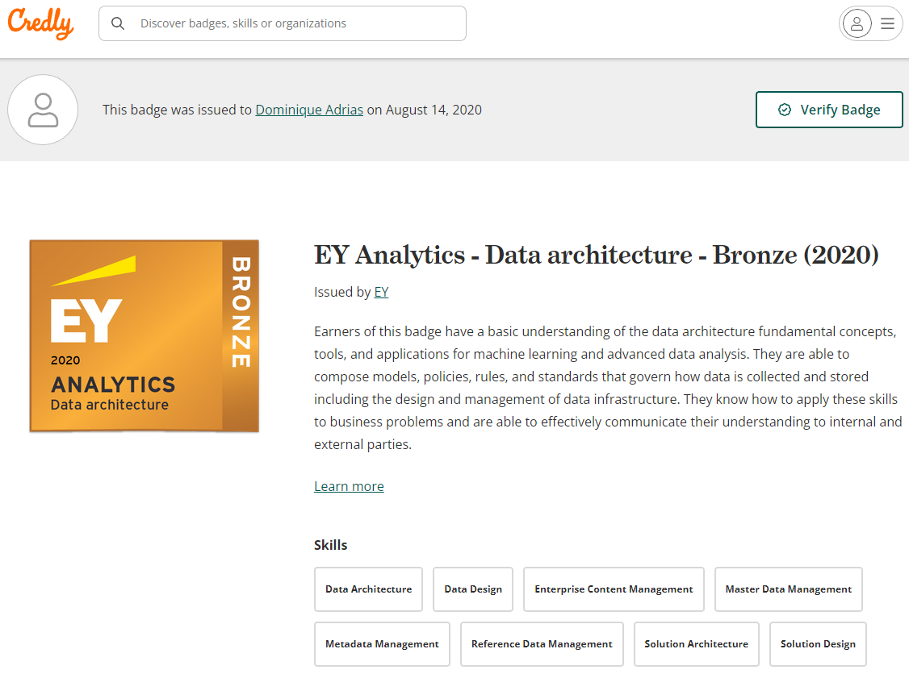

[EY Analytics - Data architecture - Bronze (2020) - Credly](https://www.credly.com/badges/1a294efb-17a8-4756-bf1d-6a38e4ddf3b6)

# EY Analytics - Data Integration - Learning (2021)

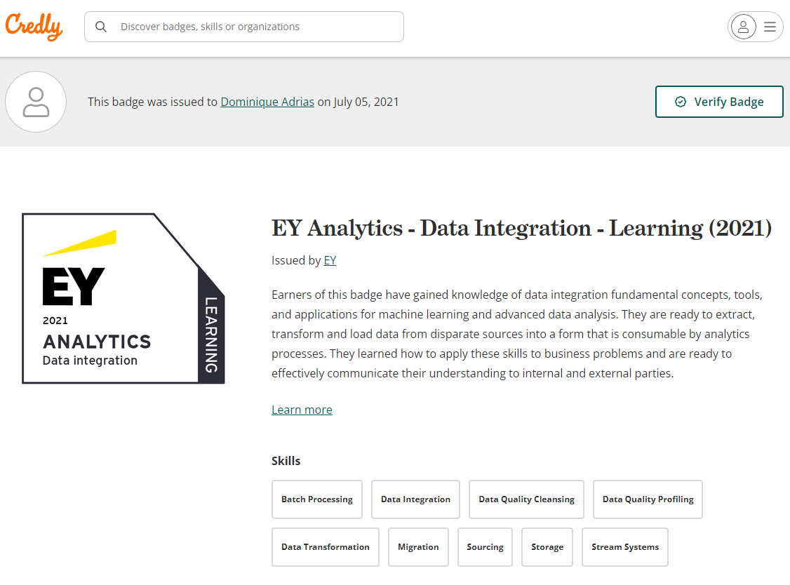

[EY Analytics - Data Integration - Learning (2021) - Credly](https://www.credly.com/badges/c358df24-d75a-4e19-83d2-52a65862c6c5?source=linked_in_profile)

# EY Data Strategy - Data Architecture - Learning (2021)

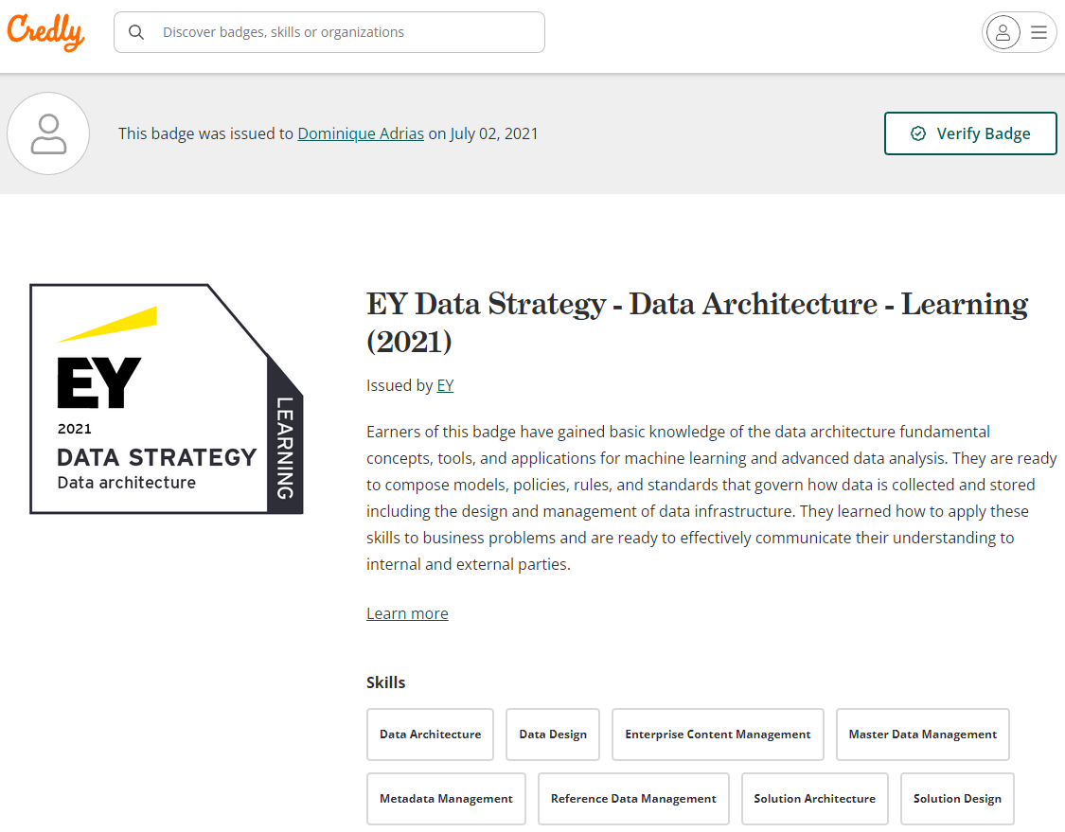

[EY Data Strategy - Data Architecture - Learning (2021) - Credly](https://www.credly.com/badges/e6ab4b8f-2f5b-40de-97f0-ebd8e2be363b)

**EY Analytics - Data Visualization - Learning (2021)**

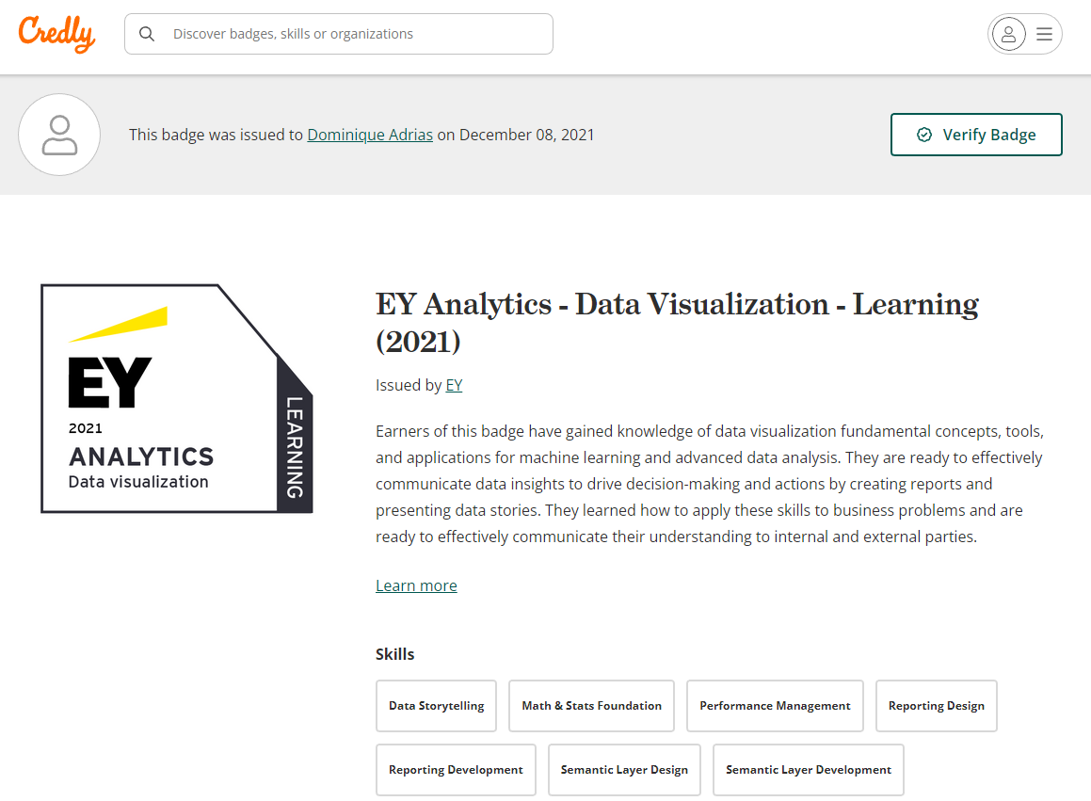

[EY Analytics - Data Visualization - Learning (2021) - Credly](https://www.credly.com/badges/64398a05-f4ee-470c-a8cb-b8610b346bb9)

# EY Analytics - Data Science - Learning (2021)

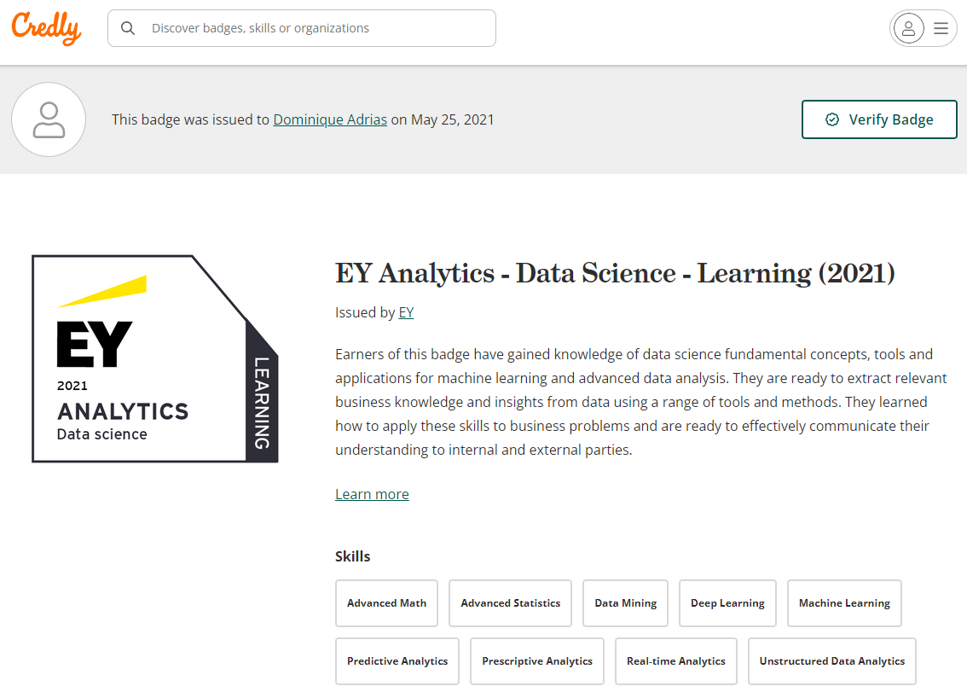

[EY Analytics - Data Science - Learning (2021) - Credly](https://www.credly.com/badges/055b0f1a-b282-44ac-a577-01c99ede8304)

Advance Excel Formulas and Functions

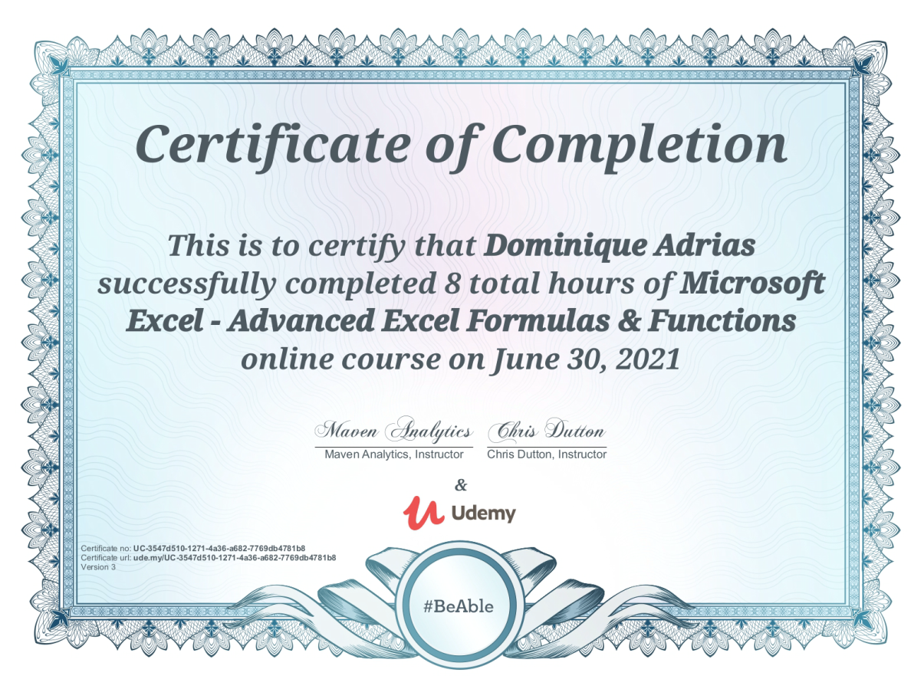

Apache Hadoop Exam Result 1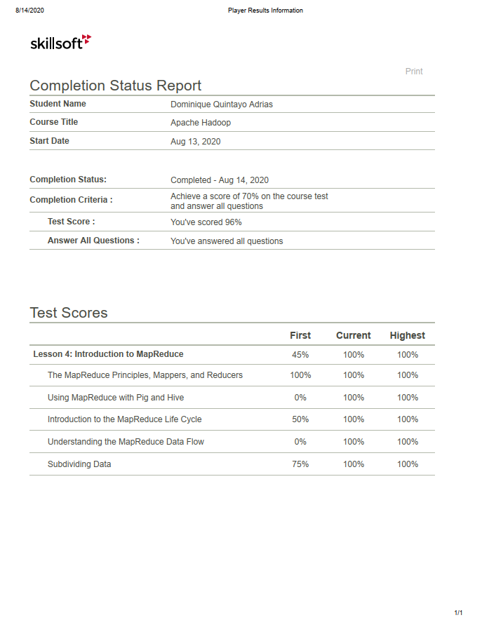

Apache Hadoop Exam Result 2

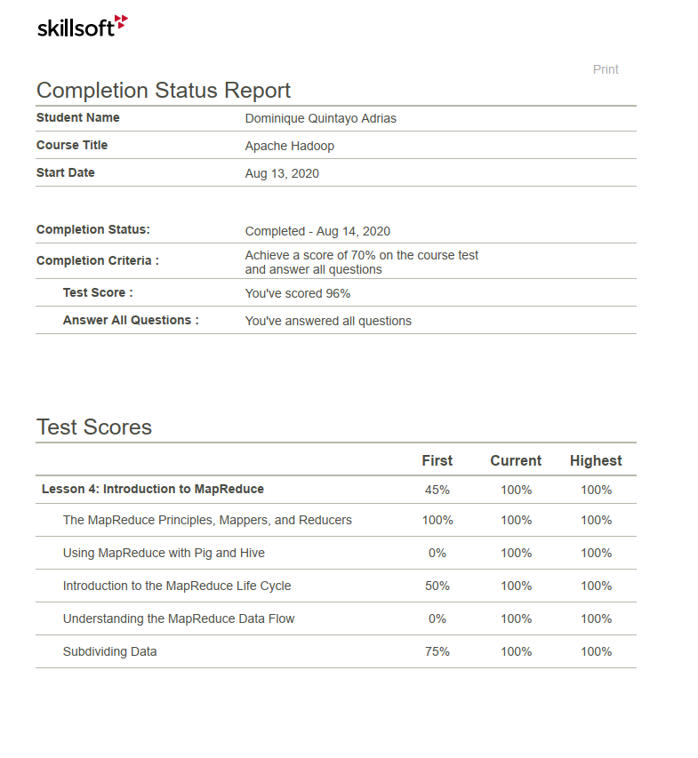

Apache Hadoop Certification

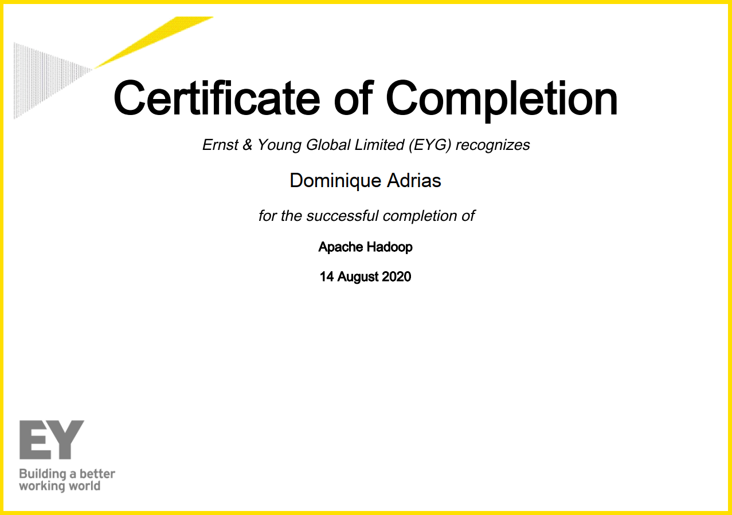

Azure Architect Design Exam

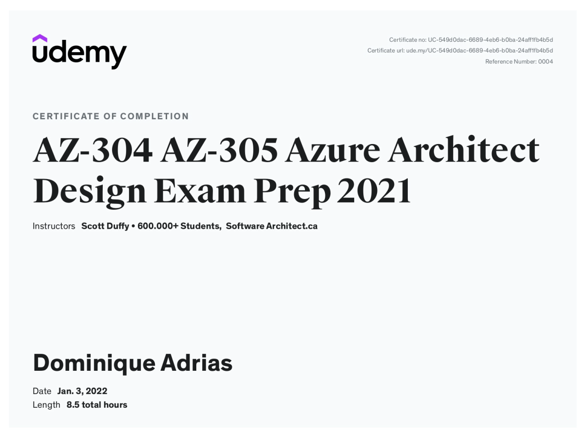

Azure Architecture Technology Exam

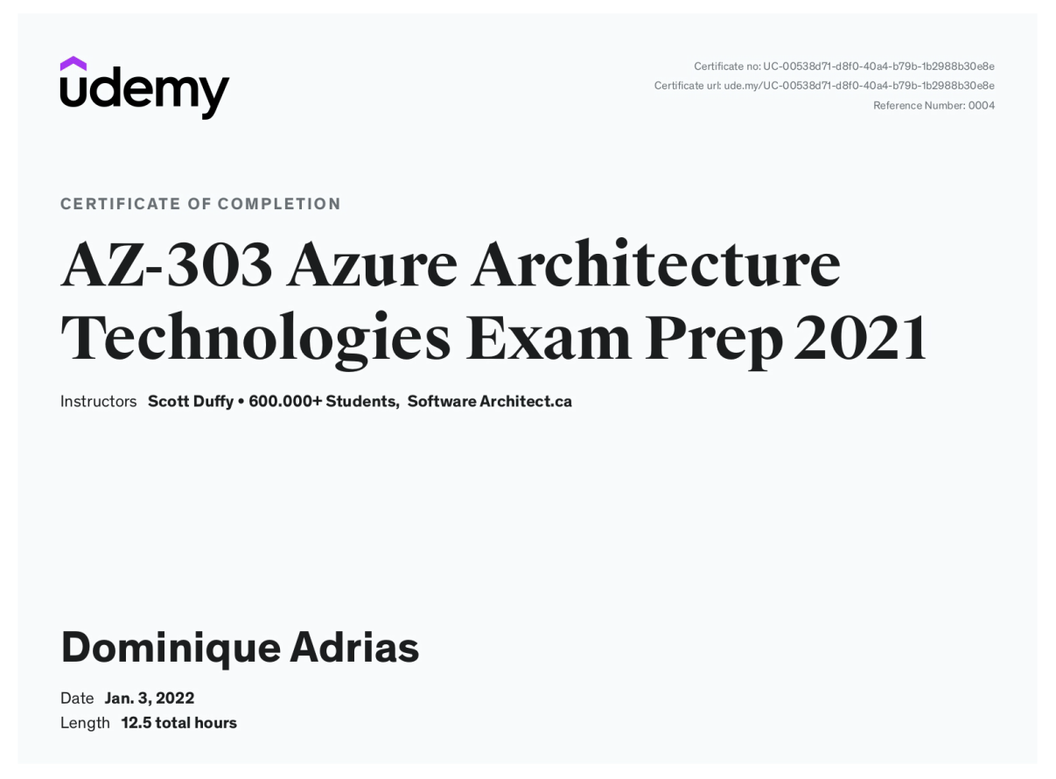

Big Data Technology Wave Exam Results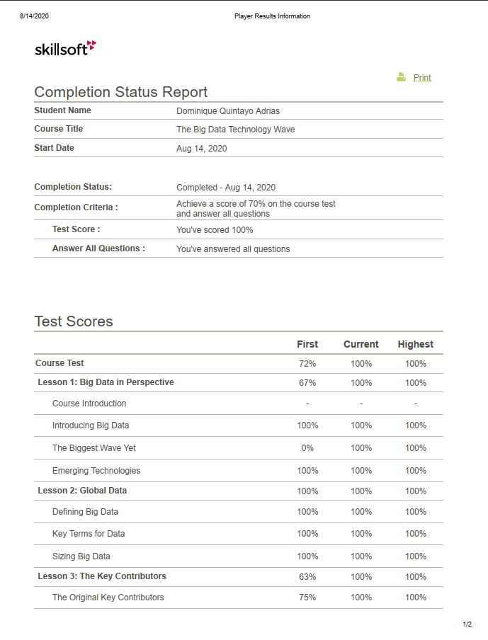

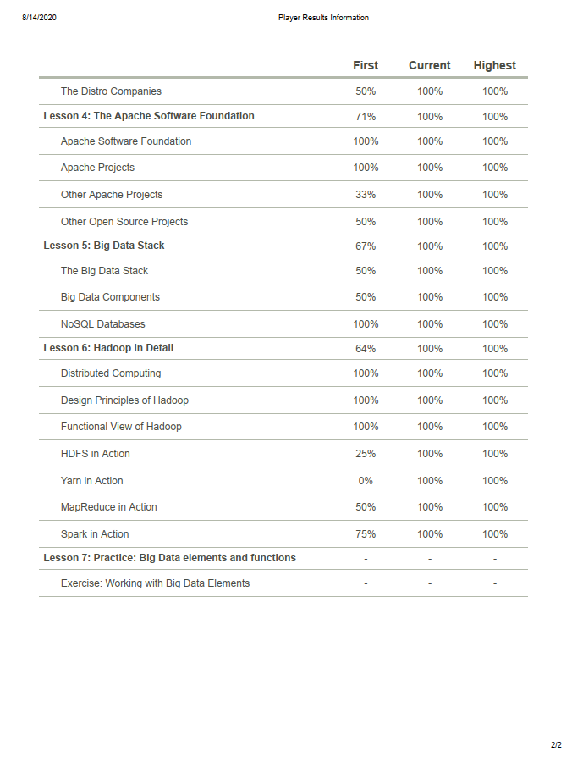

Certification for Power Bi - Module 1 - Power Query

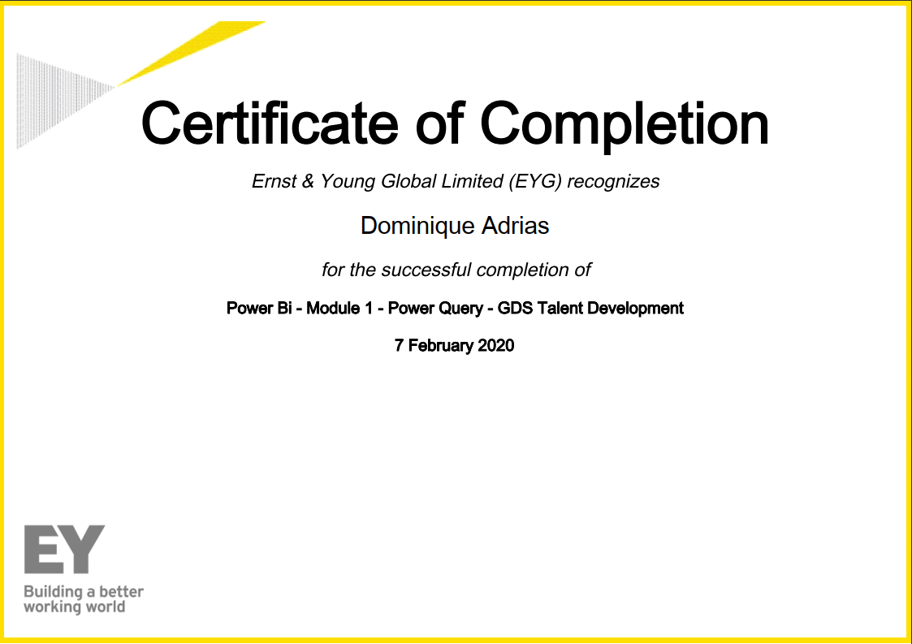

Certification for Power Bi - Module 1.2 - Power Query

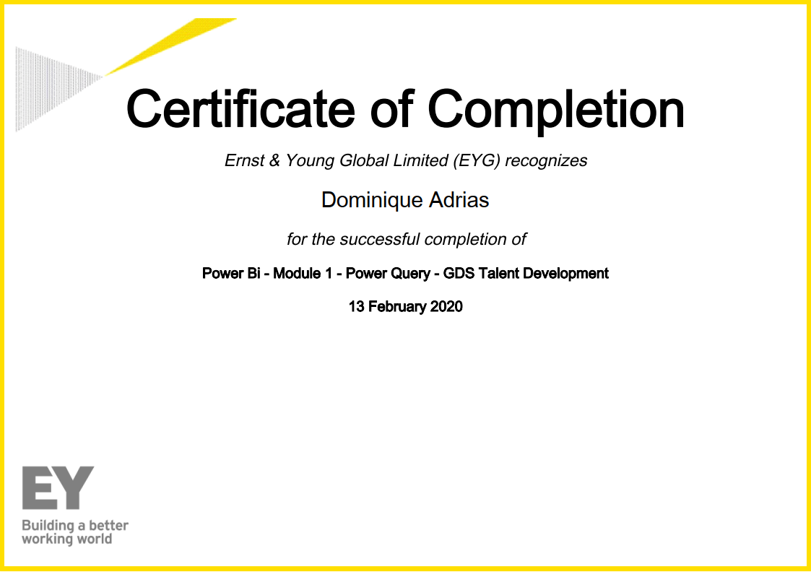

Certification for Power Bi - Module 2 - Power Pivot 1

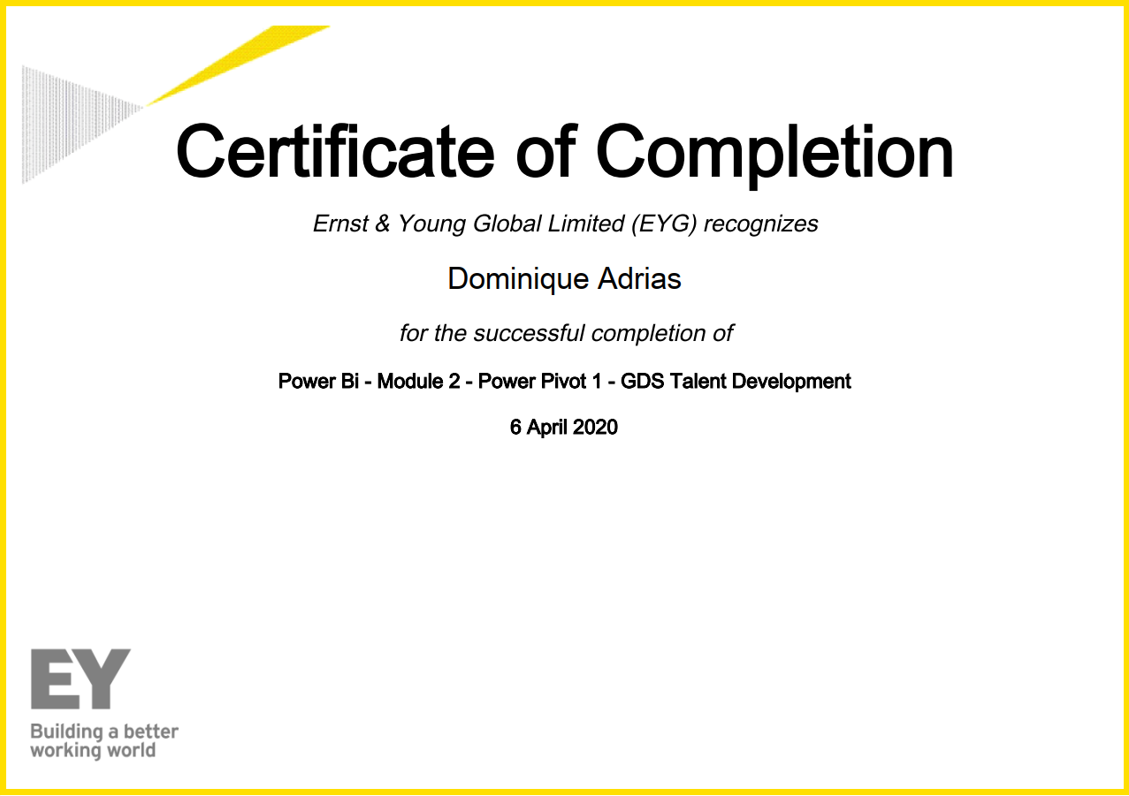

Certification for Power Bi - Module 2 - Power Pivot 2

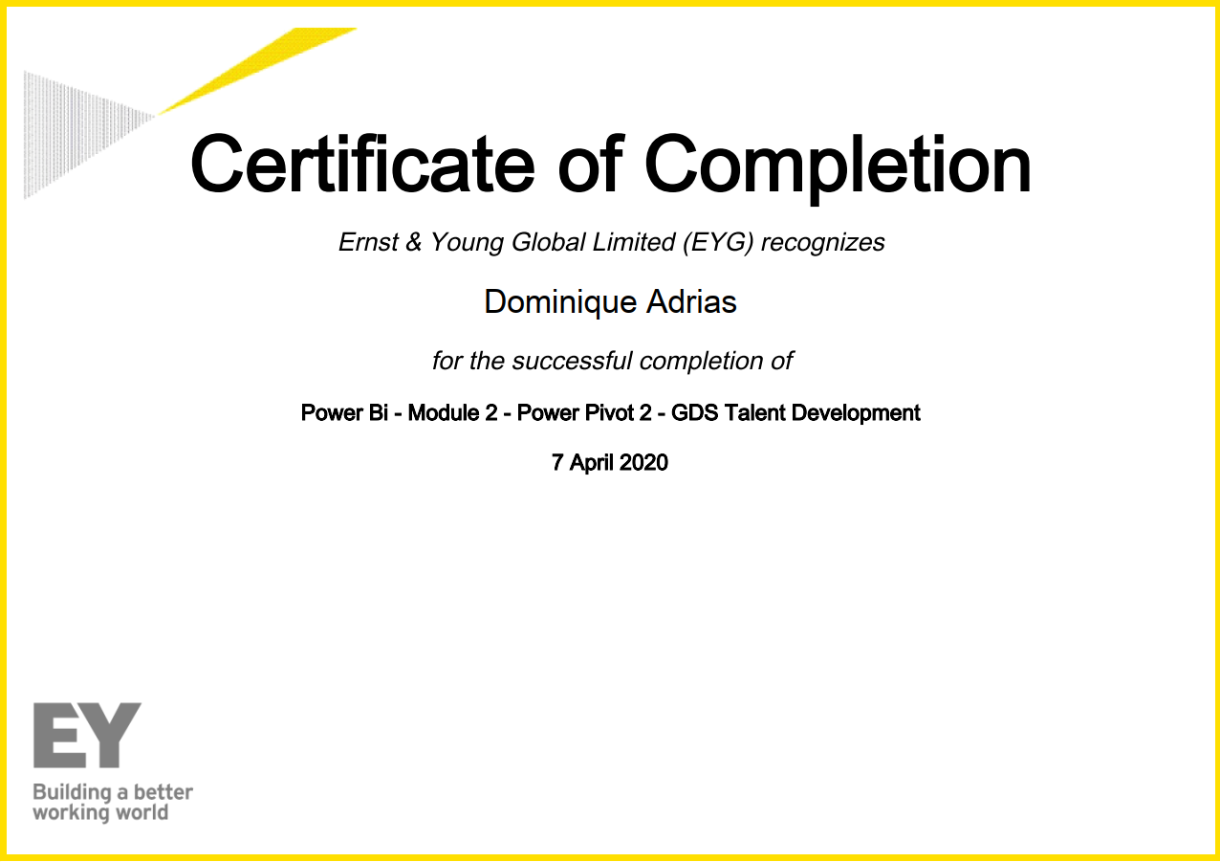

Certification for Power Bi - Module 2 - Power Pivot 3

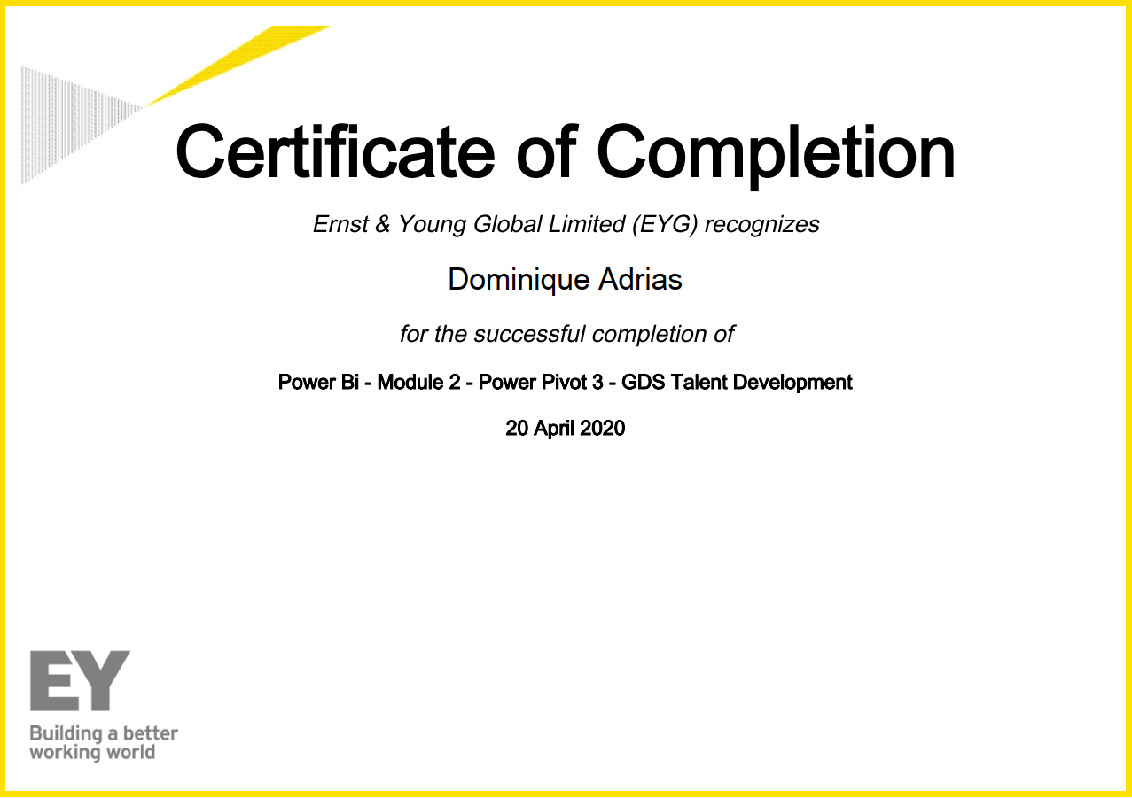

Certification for Power Bi - Module 2 - Power Pivot 4

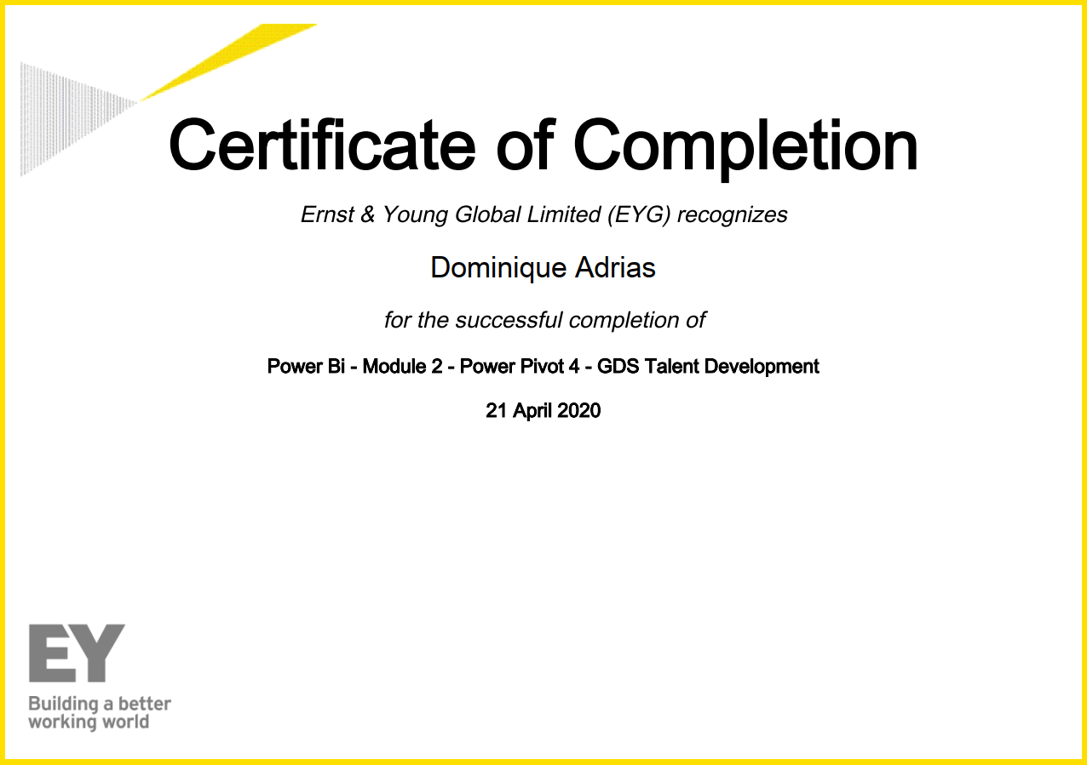

Certification for Power Bi - Module 3 Data Visualization and Dashboards 1

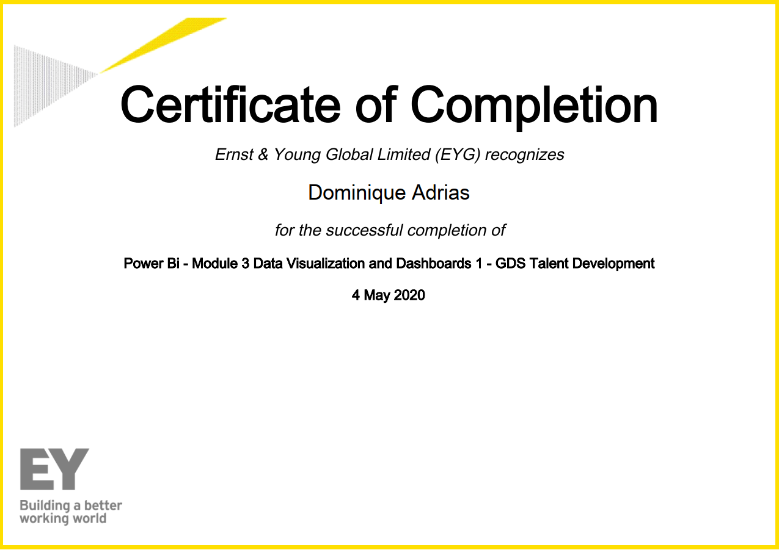

Certification for Power Bi - Module 3 Data Visualization and Dashboards 2

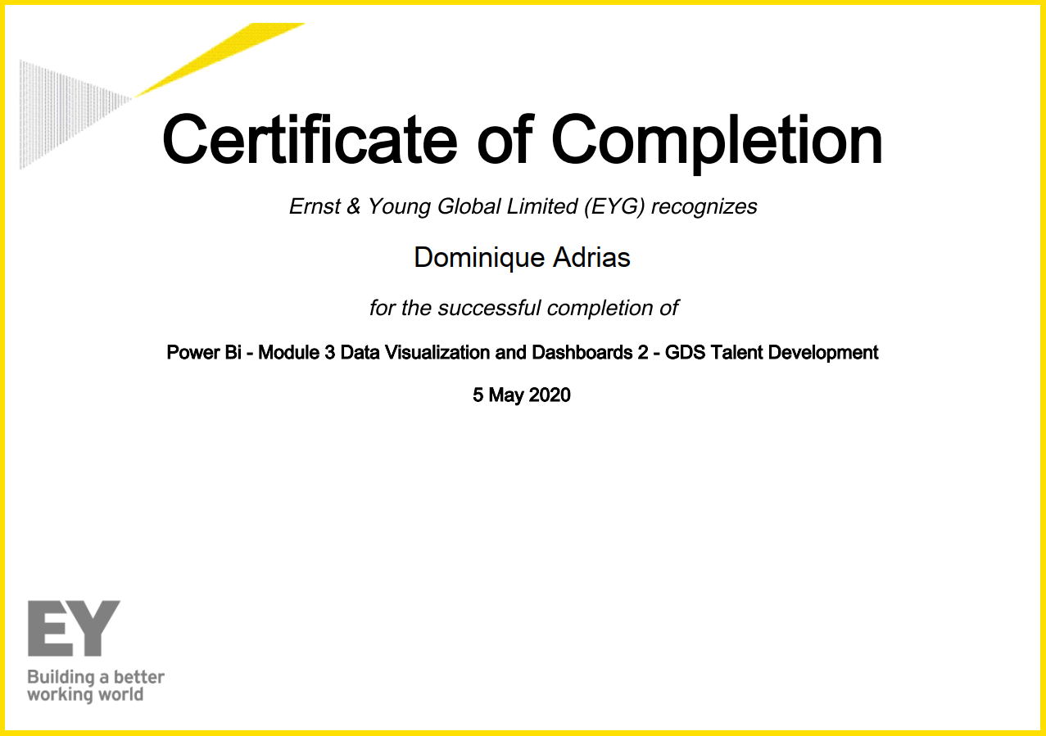

Certification for Power Bi - Module 3 Data Visualization and Dashboards 3

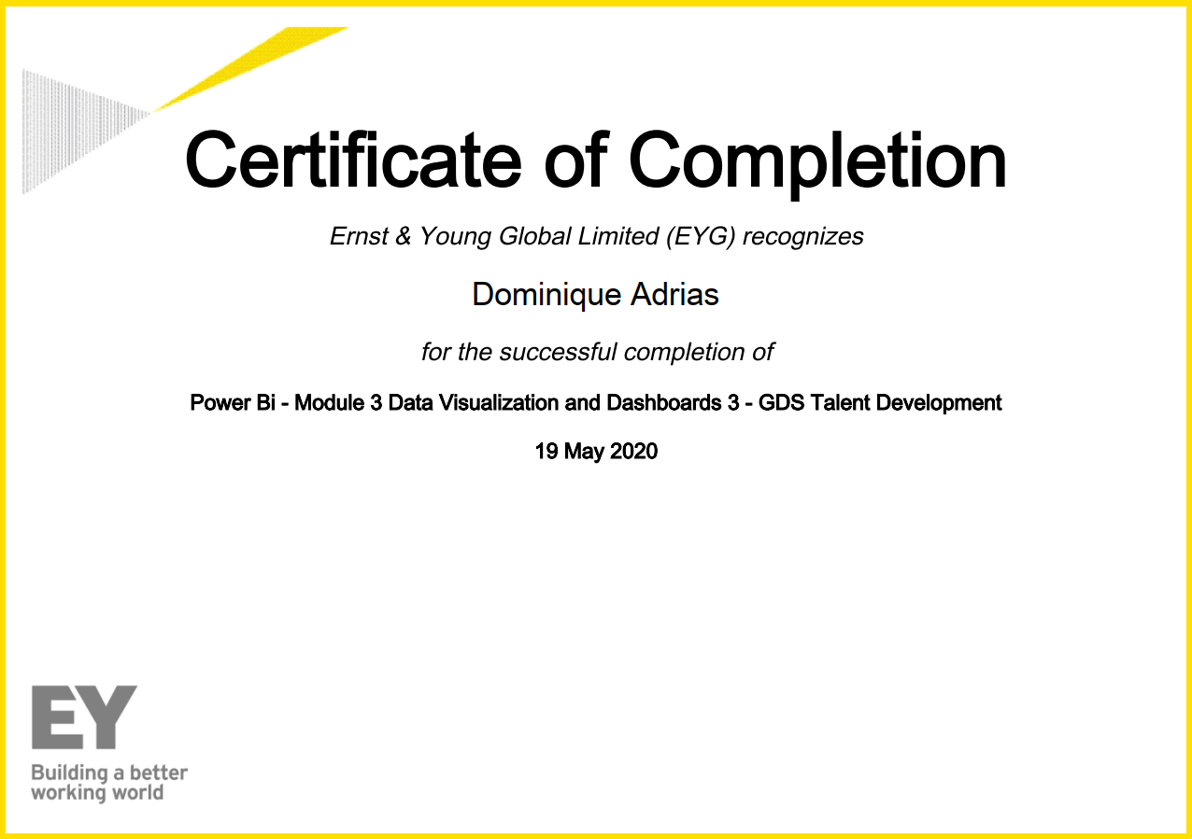

Certification for Power Bi - Module 3 Data Visualization and Dashboards 4

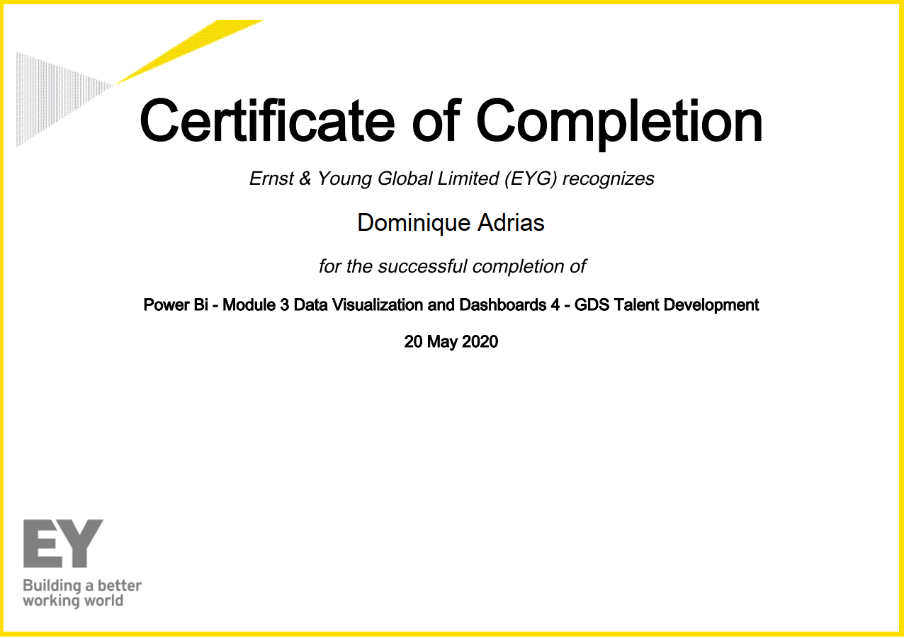

Certification for Power BI Master Class - Dashboard and Power BI Services

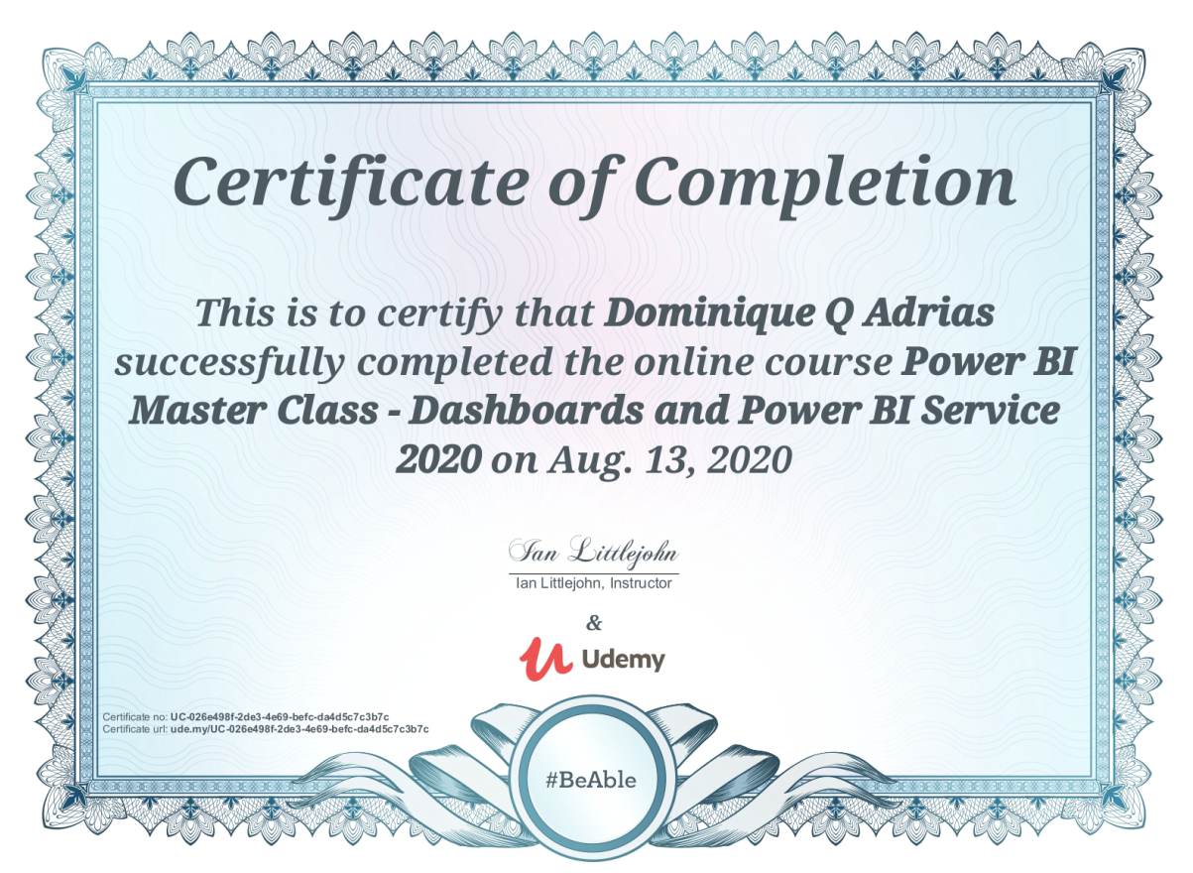

Cloud Computing for the Business User Proof of Completion

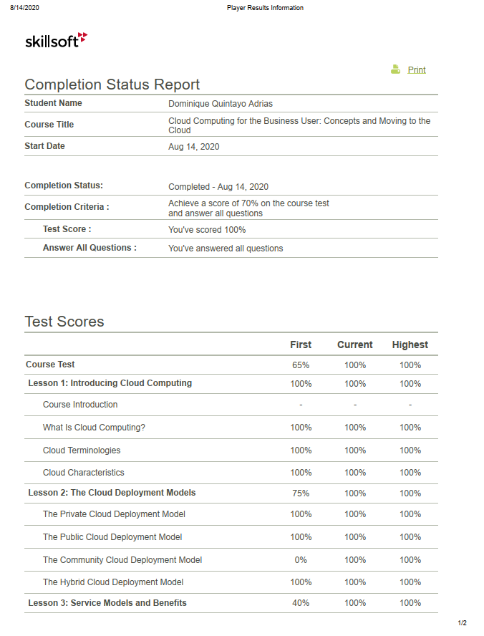

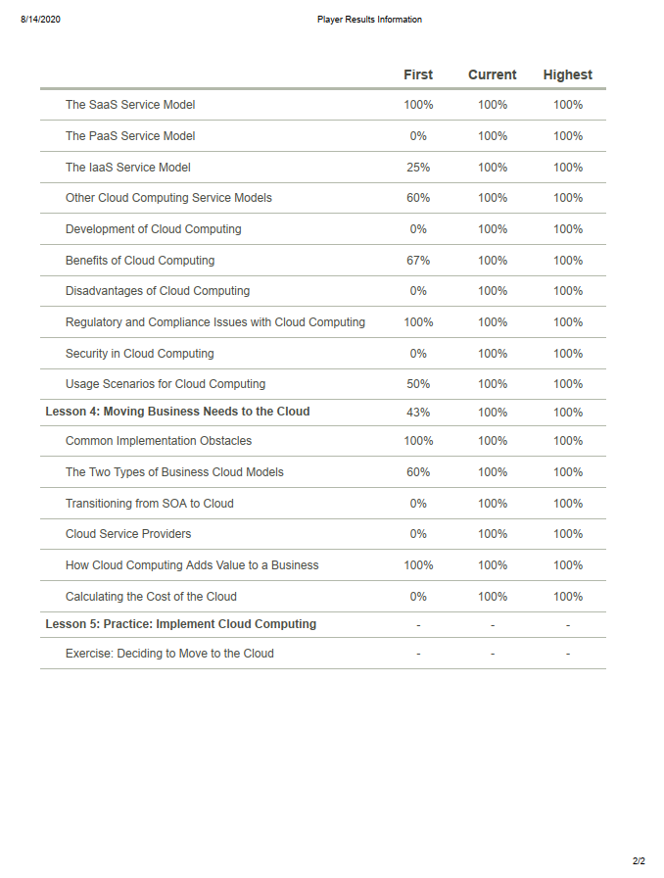

Data Visualization with Python Matplotlib

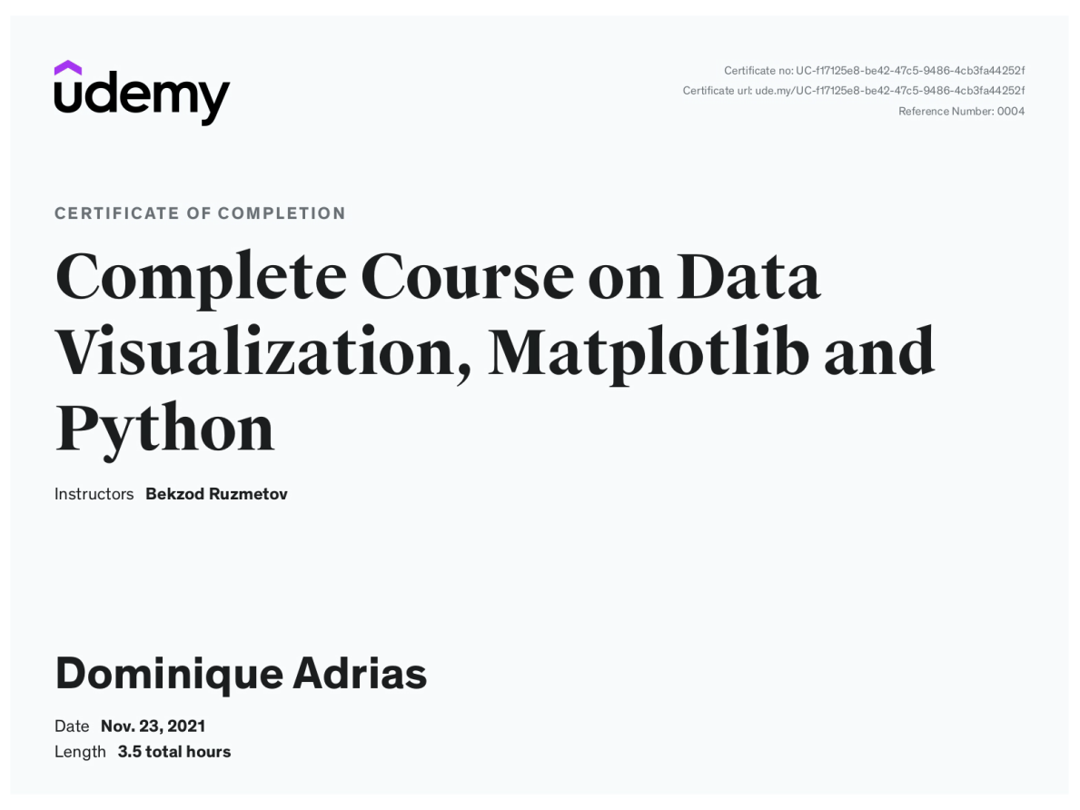

Intro to Machine Learning for Data Science Certificate

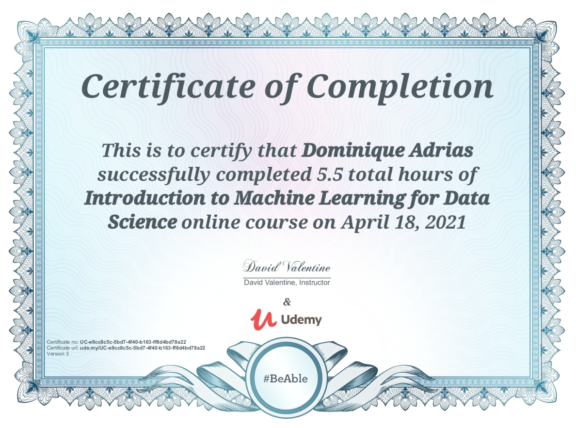

Mastering SQL Server 2016 SSIS

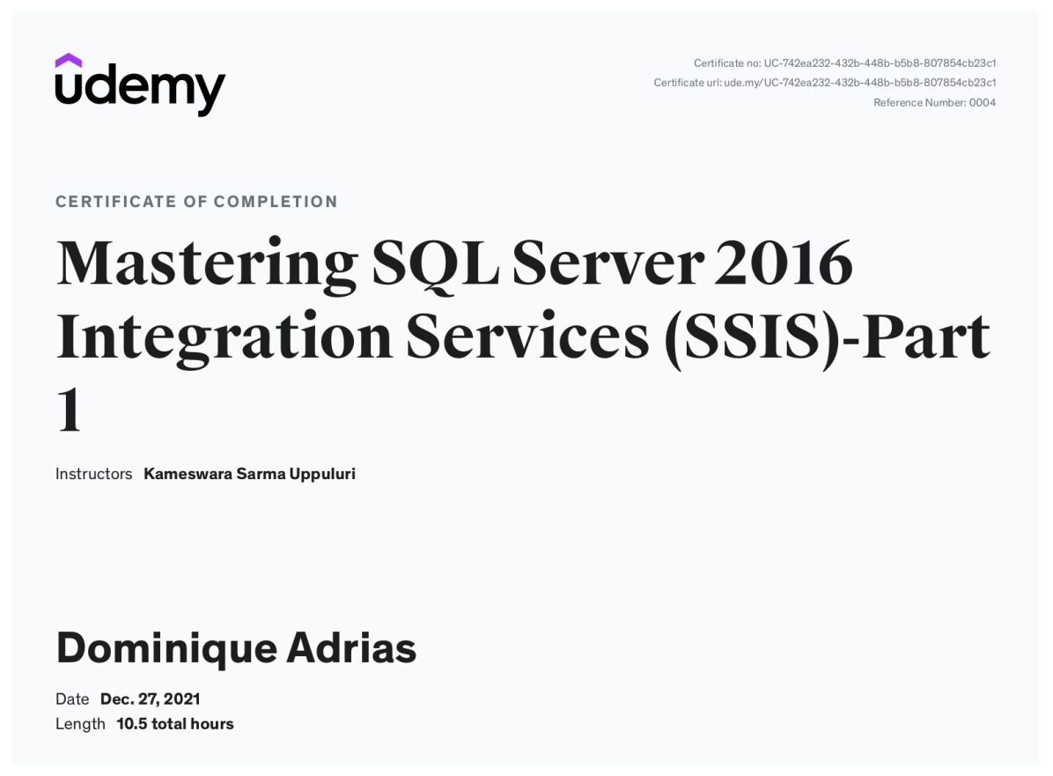

Microsoft Power Business Intelligence Certificate

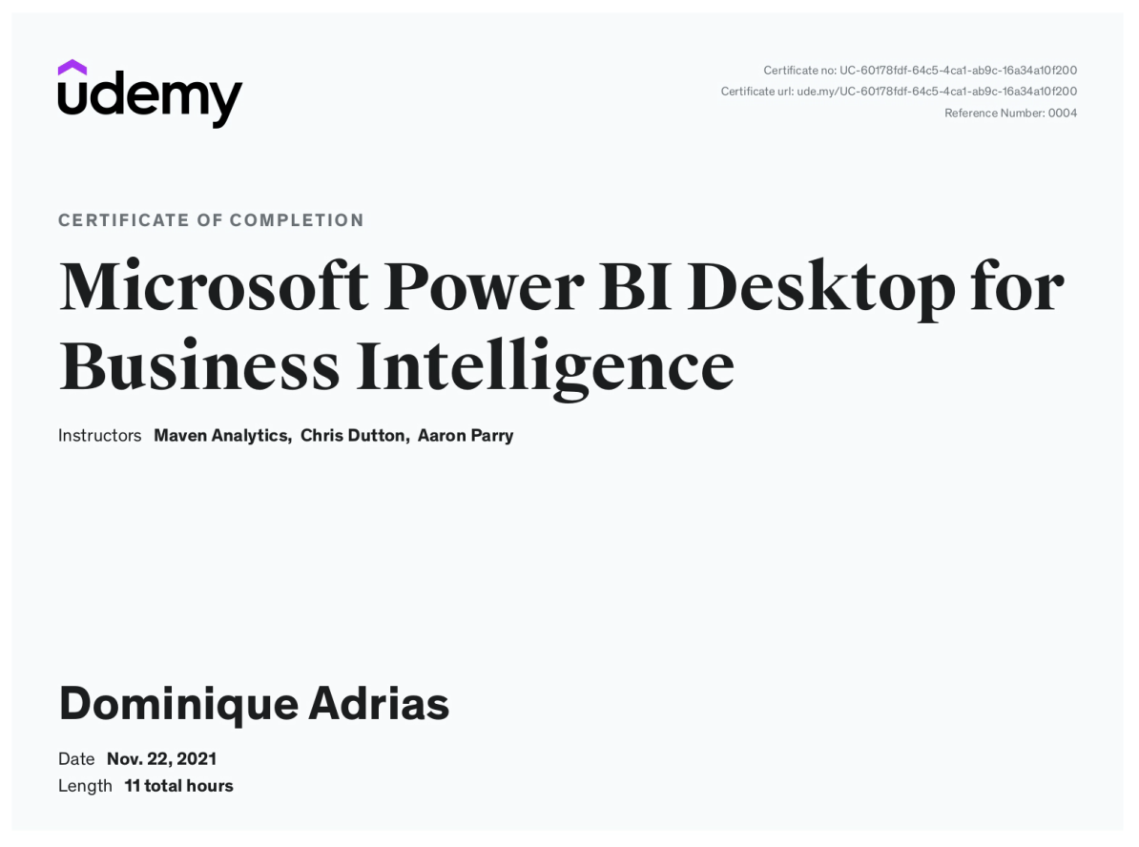

Python A-Z™ Python for Data Science Certification

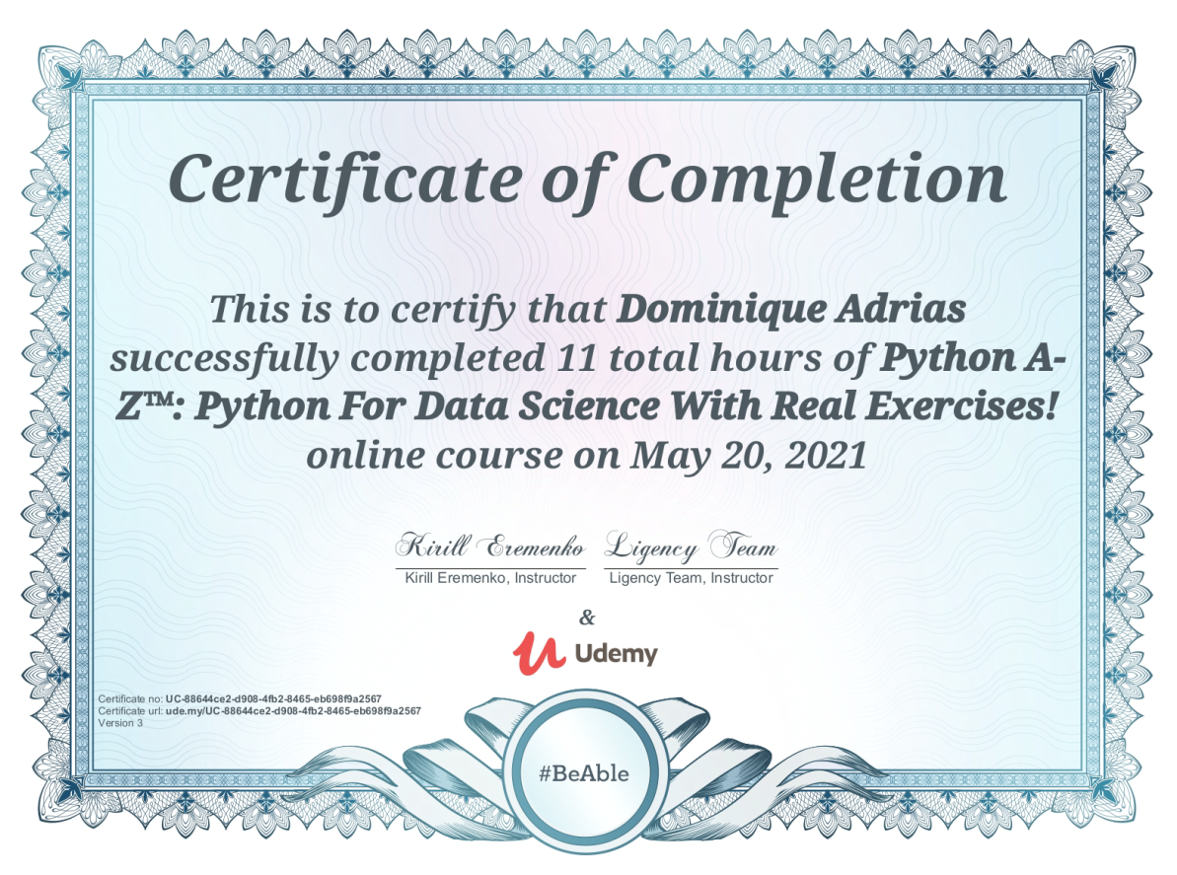

The Complete SQL Bootcamp 2020 Certification

